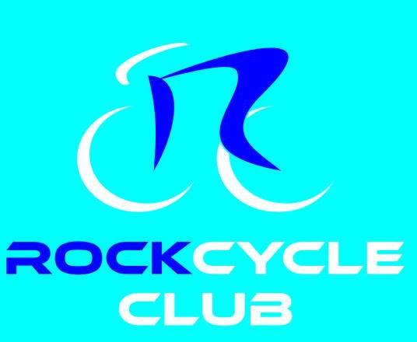
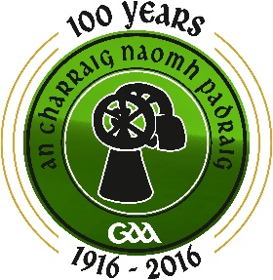
REGISTRATION FORM
NAME:__________________________________________________
ADDRESS: __________________________________________________
MOBILE: __________________________________________________
EMAIL : __________________________________________________
AGE GROUP(circle) 36-50 over 66
16-25
51-65
26-35
TYPE OF CYCLIST (please tick)
NON-CYCLISTS (People who have not ridden a bike for several years)
SOCIAL CYCLISTS (People who has been cycling intermittently over the years)
REGULAR CYCLISTS (People who cycle regularly throughout the year / Club)
PREFERRED ROUTE OPTION (Provisional)
100 kilometres 50 kilometres
CYCLE JERSEY SIZE

2XS XS S M L XL 2XL 3XL
SANDWICH MENU (PLEASE CIRCLE SELECTION)
Chicken - SALAD NO SALAD
Ham - SALAD NO SALAD
Tuna - SALAD NO SALAD
ALL SANDWICHES WILL HAVE BUTTER AND MAYO UNLESS OTHERWISE STATED BELOW.
Special requirements ______________________________________________
DECLARATION
I will raise sponsorship of £100 and pay £40 for registration (£150 sponsorship for 2 people in one household) This payment will cover the cost of the cycle jersey, sandwiches, snacks and water throughout the cycle and my ticket to fork supper and entertainment afterwards. Prizes will be awarded to the Top Sponsorship Earners.
I understand that the organisers will not be liable for any loss, damage or injury whatsoever directly or indirectly or resulting from the negligence, wrongful act or the fault of the organisers of Rock Saint Patricks GAC or any act of God, or the physical condition of the entrant.
I wish to confirm that the Rock Saint Patricks GAC have strongly advised that I become a member of the Rock Cycle Club or Cycling Ireland to avail of their insurance benefits

Signed: ____________________________________________
Date: _______________________

